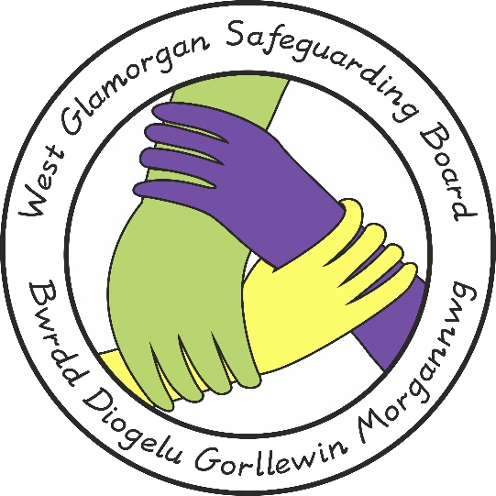

West Glamorgan Safeguarding Board

Multi-Agency Protocol for the Resolution of Professional Differences

Document Author: POLICY, PRACTICE & PROCEDURE MANAGEMENT GROUP
Approved by: WGSB
Issue Date: 23rd of November 2020
Review On the: 2nd of February 2023
Next Review Date: 2nd of February 2026

MULTI-AGENCY SAFEGUARDING PROTOCOL FOR THE RESOLUTION OF PROFESSIONAL DIFFERENCES

- Introduction

  - Regional Safeguarding Boards operate under Part 7 of The Social Services and Well-being (Wales) Act 2014. Key functions and principles are to protect children and adults in their area who may be experiencing or at risk of abuse, neglect and other kinds of harm and; to prevent children and adults in their area from becoming at risk of abuse, neglect and other kinds of harm.
This requires professionals and agencies to work together collaboratively and in partnership via the various arrangements that are in place under the West Glamorgan Safeguarding Board’s Structure (Appendix A). The West Glamorgan region has a strong history of multi-agency partnership working. It is inevitable that on occasions professional differences will occur within the context of complex safeguarding work.
  - Each agency working with children and adults at risk has an important contribution to make towards safeguarding and promoting wellbeing and good outcomes in accordance with their roles and responsibilities. All individual professionals or staff members are required to work cooperatively within the context of relevant legislation, which includes The Social Services and Well-being (Wales) Act 2014, The Children Act 1989, as well as the Wales Safeguarding Procedures (2019).
  - When professional differences occur that cannot be resolved informally, it is essential that all individual professionals or staff members are able to constructively and critically challenge the practice and decisions of others. Managers are therefore responsible for ensuring that their staff are supported when they want to report concerns and disagreements within their own organisation and/or between agencies.
  - The Resolution of Professional Differences Protocol does not replace the Wales Safeguarding Procedures (2019) and is separate and distinct from Whistle-blowing arrangements within agencies.

- Principles for Managing Professional Differences

  - Some common, but not all, reasons for professional disagreements within a safeguarding context include:

    - Criteria for reports/referrals
    - Outcome of assessments
    - Roles and responsibilities of workers
    - Service provision
    - Timeliness of intervention
    - Information sharing and communication
    - Practice case/management issues.
    - Thresholds
  - Professional differences of opinion should always be resolved in a constructive and timely manner. It is therefore necessary for all parties to ensure that the resolution process does not adversely affect a child or adult’s circumstances. It is important to note this protocol encourages any professional differences that are identified to be resolved via discussion – practitioner to practitioner - and resolution wherever possible as opposed to unnecessary escalation.

- Process for Resolution

  - The dispute resolution must be achieved within the following three stages (See Appendix B for Flow Chart).

Informal:

  - This is the initial phase to resolve differences between professionals. It encourages practitioner to practitioner discussion and collaborative working. As indicated in 2.2, wherever possible, professional differences should endeavor to be resolved at this stage without any unnecessary escalation. The individual professionals or staff members should initially attempt to resolve the differences together through discussion and/or a meeting. The professional or staff member should raise their concerns to the individual they have a professional difference with and ask to discuss/meet within 5 working days, or a timescale that ensures that a child or adult is safeguarded from harm, whichever is less. The individual professionals or staff members will seek to resolve their differences and work towards a mutually acceptable solution.
  - All parties should keep a written record, of the professional difference and the agreed resolution, which should be saved on the child/adult’s case file held by the respective agencies.
  - If the professional difference has arisen because of a lack of clarity about a procedure or the absence of a procedure, internal processes are to be followed to ensure this is considered by the relevant organisation. Any such issues should also be referred to the West Glamorgan Safeguarding Board Business Management Unit (BMU) who will log and share with the Policies, Procedures and Practice Management Group (PPPMG) for consideration.

Stage 1:

  - Stage 1 is considered the start of the formal process for dispute resolutions. If the matter is not resolved informally, the individual professional(s) or staff members should bring the matter to the attention of their line manager(s), or an appropriate level of management, who should have a discussion and/or convene a meeting with the relevant manager of who the professional difference is with, within 10 days of being notified of the dispute.

  - It is the responsibility of each respective manager to access and review any relevant information, and have a discussion with the individual professional or staff member, and record on Appendix C the reason for the disagreement and the agreed outcome within the child/adult’s file held by the respective agencies.
  - The following steps are required:

    - Recognition and acknowledgement that there is a professional difference about a significant safeguarding issue;
    - Identification and clarity about the professional difference and the desired outcome of both parties;
    - The achievement of an agreed outcome and identification of continuing concerns expressed by either party.
  - There should be a written record of all discussions/meetings/consultations undertaken at this stage. In particular it must include written confirmation about agreed outcomes and in the event of continuing unresolved matters how they will be addressed.
  - A record of all professional difference(s) triggered at Stage 1, including subsequent follow up (e.g. Resolution or escalation through the further stages) will be shared with the Safeguarding Board Business Management Unit (BMU). This will allow the BMU to hold a data-base to track all professional differences and to identify themes, patterns and trends and provide assurances to the Safeguarding Board on the effectiveness of this process.

Stage 2

  - In exceptional circumstances, when individual professionals or staff members are unable to resolve their differences at Stage 1, the matter must be reviewed by an agency senior manager within 10 working days of the Stage 1 decision, or a timescale that protects the child or adult from harm, whichever is sooner. The Head of Service and/or the Strategic Lead and Chair of the Safeguarding Board (WGSB) will be sighted on any dispute that reaches Stage 2 and the outcome, which will be shared with the Executive Board.

  - The managers in Stage 1 will discuss the issue with the Senior Manager who will brief the Head of Service (or Agency Equivalent). The Head of Service (or Agency Equivalent) will decide the appropriate Senior Management level at which the matter should be reviewed based on the nature and seriousness of the dispute.
  - The Designated Senior Manager will then arrange a meeting, within 10 days of Stage 1 decision, and contact the relevant individual professionals or staff members. The meeting will be arranged and conducted in the following way:
    - The senior managers will agree an attendance list, which may include the managers or designated staff with responsibility for safeguarding children/adults in the respective agencies;
    - The identified lead agency senior manager will chair the meeting and provide administrative support;
    - The senior managers conducting the meeting will have access to appropriate records and have the discretion to instigate an internal management review within their own agency if they consider this appropriate;
    - The meeting will decide on an outcome of the dispute and record this; and
    - All parties should accept the outcome of the dispute resolution meeting.

Stage 3:

  - In the unlikely event that the matter cannot be resolved at Stage 2 of the process, the matter will be reviewed, within 5 days of the Stage 2 decision, by a Co-chair of the Safeguarding Board whose agency was not directly involved in the original dispute

- Monitoring and Quality Assurance

  - The Regional Safeguarding Board will monitor, periodically review and audit the number of cases in which the dispute resolution protocol has been instigated as part of its quality assurance/performance framework. This will help identify any particular themes and trends within a regional context. The Quality and Practice Management Group are required, as part of their quarterly data set, to capture and record this information and report it to the Safeguarding Board.

Appendix A

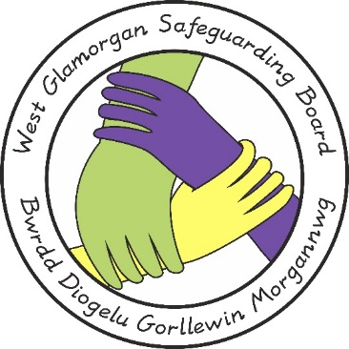

West Glamorgan Junior Safeguarding Board

Practice Review Management Group

Joint Policy, Procedure and Practice Management Group

WEST GLAMORGAN SAFEGUARDING BOARD
West Glamorgan Safeguarding Children & Adults Boards

Joint Quality and Performance
Management Group

Joint Strategic Training Management Group

Appendix B

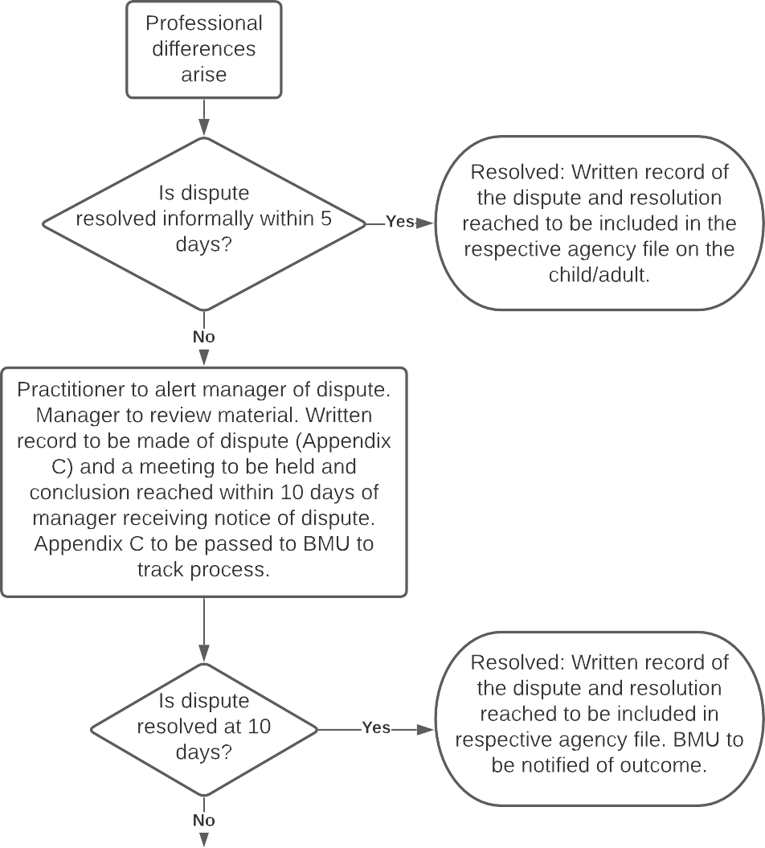
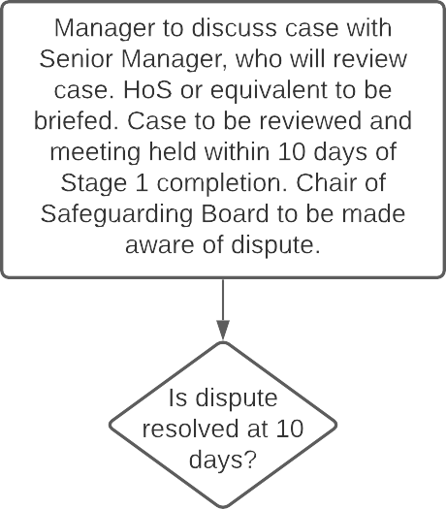
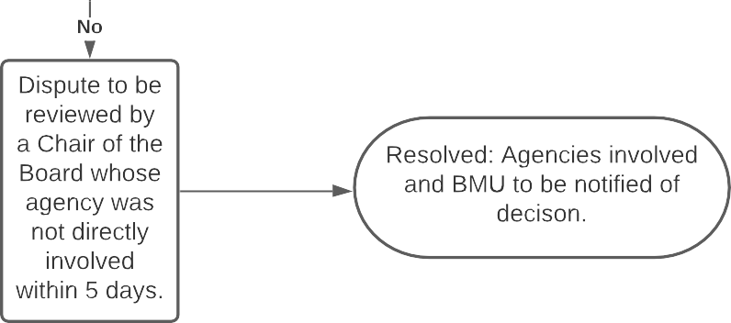

Stage 3

Appendix C

Resolution of Professional Differences Report

Child’s/Adult’s name
Case ID
Age of Child(ren)/Adult
Case holding/Decision-making Team
Subject i.e. Threshold on Physical Abuse case; FII policy not followed etc. (Succinct)
Summary Of Reason
For Dispute – Include
Views Of All Agencies
Concerned

Agreed Outcomes Or
Actions If Satisfactorily
Resolved – Includes
Escalation To Next
Stage If Unresolved

Agency/Organisation Raising The Professional Difference | Name:
 | Designation:
 | Agency:
 | Date:
Agency/Organisation Receiving The Professional Difference | Name:
 | Designation:
 | Agency:
 | Date:

Please Complete For Monitoring Purposes:
Stage At Which  Resolution Achieved-  1, 2, 3 | Time Taken To Reach Resolution- | Please Note How Effective This Protocol Was In Resolving The Issue And Please Make Suggestions As To How The Protocol Can Be Improved:
Additional Notes:

Contact
If you have any queries about the content of the attached document, please contact:

Rebecca Shepherd
Business Manager – West Glamorgan Safeguarding Board
Tel/ Ffôn: 01639 686049
Mobile: 07964 246849
Email: r.shepherd@npt.gov.uk
Website/ Gwefan – www.wgsb.wales

